**TASK 4 – OLAP Operations**

-- **4. PERFORM OLAP OPERATIONS**

**-- a) Drill Down:**

**-- Drill down from region to product level to understand sales performance. This query shows sales for each product within each region.**

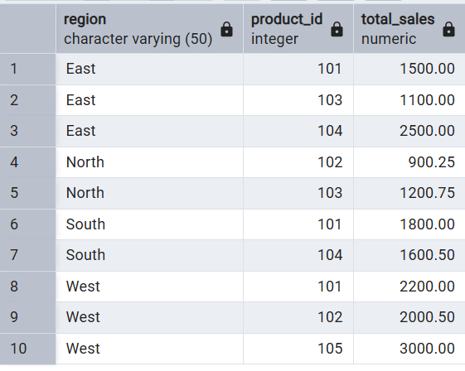

**B) ROLLUP**

Rollup from product to region level to view total sales by region. This query uses GROUPING SETS to show sales by product, sales by region, and overall total sales.

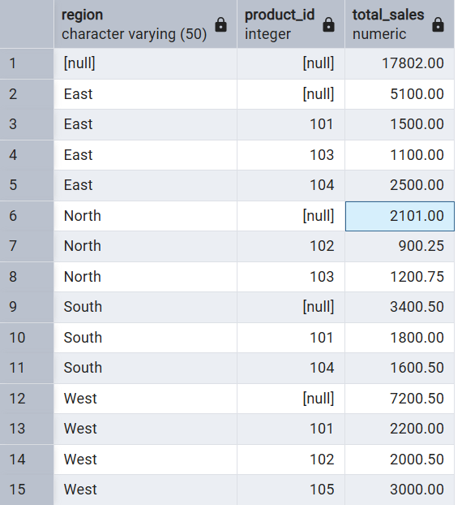

**--C) CUBE**

-- Explore sales data from different perspectives, such as product, region, and date. This query uses CUBE to generate subtotals for all possible combinations of the specified dimensions.

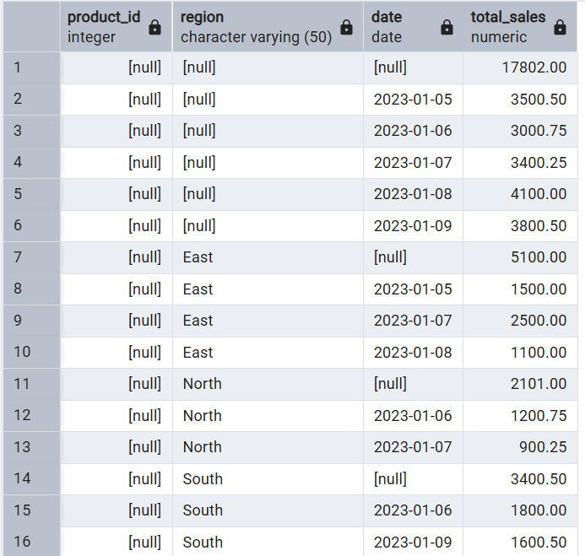

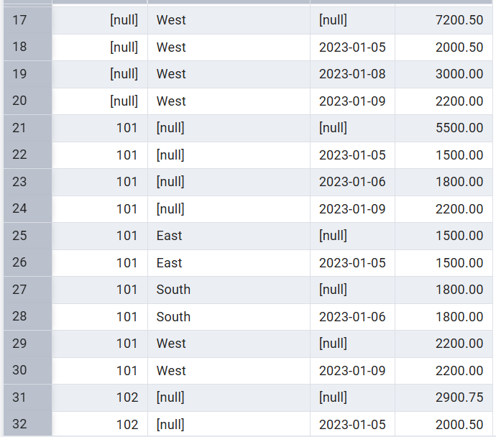

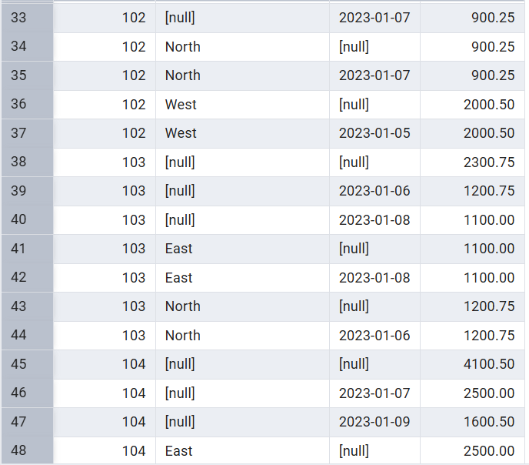

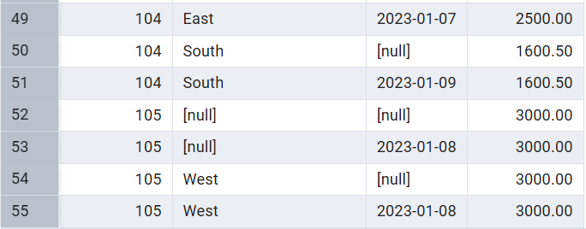

**-- D) SLICE**

-- Extract a subset of data based on specific criteria. This query slices the data to view sales for a particular region (e.g., 'East').

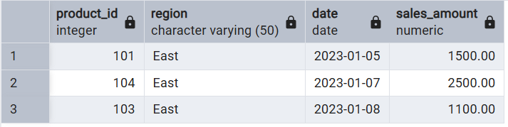

**-- E) DICE**

-- Extract data based on multiple criteria. This query dices the data to view sales for specific products in a particular region and date range.

